GURU NANAK DEV ENGINEERING COLLEGE

LUDHIANA



WT PRACTICAL (CS-14514)

Submitted By: Submitted To:

Name: Gursimar Kaur Mr Gurjeevan Singh

Roll no: 1820036 (Uni.)

Class: D3 CS E3

**Experiment-1**

**Aim: Configuration and administration of IIS and Apache Web Server.**

What is IIS?

IIS is a web server that runs on the Microsoft .NET platform on the

Windows OS. While it’s possible to run IIS on Linux and Macs using Mono,

it’s not recommended and will likely be unstable. (There are other options,

which I’ll present later). It’s versatile and stable, and it’s been widely used

in production for many years. Version 10 is the most current. Once it’s

installed you’ll see this welcome page in your browser.

Steps set up IIS SERVER:

1. Right-click on the Windows button on the bottom-left corner and select **Run** and type in appqiz.cpl and hit enter.

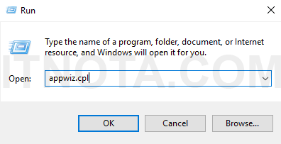

1. As soon as a new window called **Programs and Features** is opened, click on the link **Turn Windows features on or off**.

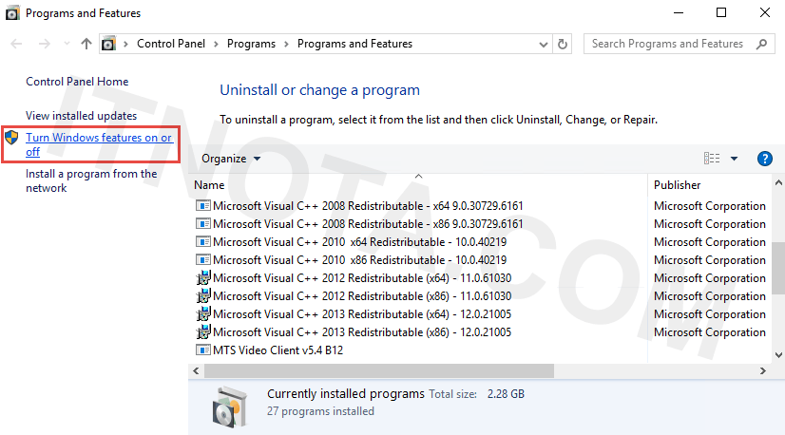

1. Click on the **Internet Information Services** checkbox. By default it will install all you need to host a website. Once done, click **OK** and **Close** when it says “Windows completed the requested changes.”

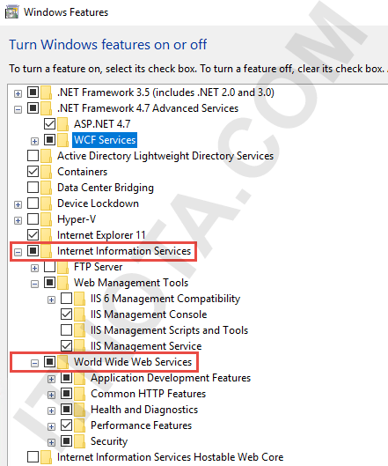

1. Now open your browser and type in **localhost** and press **ENTER**. You should see a default web page is rendered in your browser.

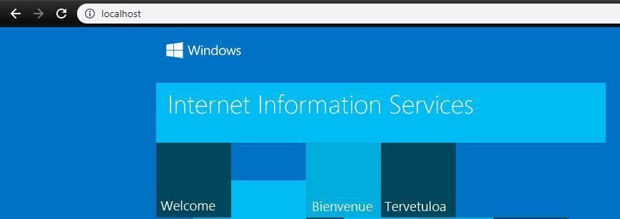

What is XAMPP?

XAMPP is a free and open-source cross-platform web server solution stack package developed by Apache Friends, consisting mainly of the Apache HTTP Server, MariaDB database , and interpreters for scripts written in the PHP and Perl programming languages .

Now we will set up apache server using ***Xampp*** app , following steps will do the same :

* + - 1. Download Xampp from “<https://www.apachefriends.org/download.html>”.
      2. Install the xampp.exe file and open up the app.
      3. Click on start button right after the ‘Apache’ to start apache services.

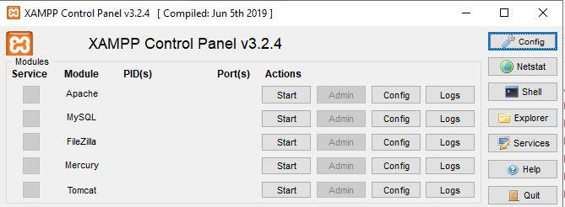

**Experiment-2**

**Aim: Develop an HTML page to demonstrate the use of basic HTML tags.**

Following code Demonstrates the use of basic html tags : >

<!DOCTYPE html>

<html>

<head>

<title>Basic Html tags</title>

</head>

<body>

<p style="font-size: 30px;">Paragraph tag</p> <!-- paragraph

tag -->

<a href="about.html">This is a link to another page using anchor tag</a>

<!-- anchor tag -->

<hr/>this is after using horizontal ruler tag

<div>

<span style="color: #6a0dad;">

<!-- using div tag -->

<ul> <!-- lists -->

<li>list element 1 (Un-ordered list)</li> <!-- span tag -->

<ol>

<li>element 1(ordered list)</li>

<li>element 2</li>

</ol>

<li>elemnt 2 (Un-ordered list)</li>

<ol>

<li> element 1 (ordered list)</li>

<li>element 2 </li>

</ol></ul></span></div>

<h1>Heading h1</h1> <!-- headings -->

<h2>heading h2</h2>

<h3>heading h3</h3>

<h4>heading h4</h4>

<h5>heading h5</h5>

<h6>heading h6</h6>

<img src="images\logo.png" style="width: 300px; height: 200px;">

</body>

</html>

<p> = this tag is used to create a paragraph.

<a> = link a web page to another web page using this tag.

<h1> to <h6> = used to define different heading sizes.

<img> = used to insert an image.

<hr> = used to insert a horizontal ruler.

<ul> = unordered list, <ol> = ordered list, <li> = list item.

<div> = used to divide page, doesn’t affect layout

<span> = used for grouping and applying styles to inline elements

**OUTPUT :**

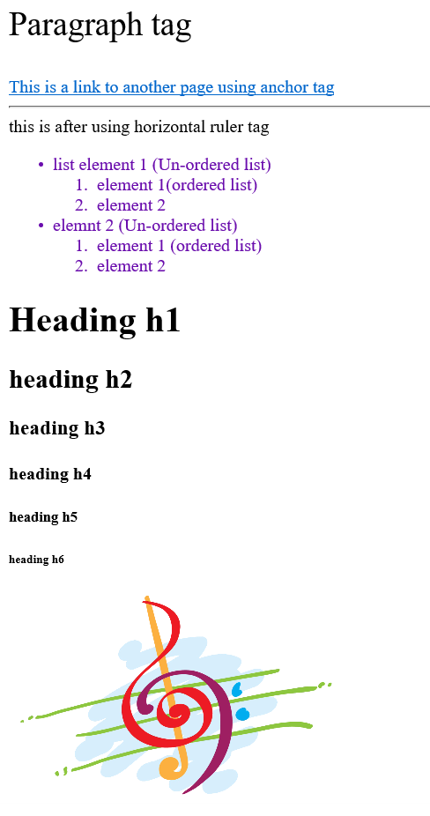

**Experiment-3**

**Aim: Create an HTML file to link to different HTML page and also link within a page.**

<!DOCTYPE html>

<html lang="en">

<head>

<title>Music</title>

<link rel="stylesheet" type="text/css" href="styles/main_style.css">

</head>

<body>

<div class="super_container">

<!-- Header -->

<header class="header">

<div class="logo">

<img src="images/logo.png" style="height: 100px; width: 100px">

</div>

<div>

<span class="logo_text">Music</span>

</div>

<div style="margin-left: 30%;">

<!-- Logo -->

<!-- Main Navigation -->

<nav class="topnav">

<ul>

<li class="active"><a href="index.html">Home</a></li>

<li><a href="artists.html">Artists</a></li>

<li><a href="blog.html">Latest Release</a></li>

<li><a href="contact.html">Contact</a></li>

</ul>

</nav>

<!-- User area -->

<div class="topnav" style="margin-left: 20%; float: left;">

<ul>

<li><a href="login.html">Login</a></li>

<li><a href="register.html">Register</a></li>

</ul>

</div>

</div>

</header>

</div>

</body>

</html>

**OUTPUT :**









**Experiment-4**

**Aim: Write an HTML file to demonstrate the insertion of images.**

Following html will add an image to web page : >

<!DOCTYPE html>

<html>

<head>

<title>Basic Html tags</title>

</head>

<body>

<img src="images\logo.png" style="width: 300px; height: 200px;">

</body>

</html>

Attributes :

Src = used to specify location of image.

Alt = value assigned to alt will appear when image fails to load.

Width = width of image in pixels.

Height = height of image in pixels.

Border = used to add border to image.

**OUTPUT :**



**Experiment-5**

**Aim: Demonstrate the creation of tables in a web page using HTML.**

<!DOCTYPE html>

<html>

<head><title>Tables and Frames</title></head>

<body>

<table border = "2px" >

<tr>

<td> Name</td>

<td>Class</td>

<td>Roll no</td>

</tr><tr>

<td>Gursimar Kaur</td>

<td>CSE3</td>

<td>1820036</td>

</tr><tr>

<td>Student 2</td>

<td>CSE3</td>

<td>1820076</td>

</tr>

</table>

</body>

</html>

**OUTPUT :**

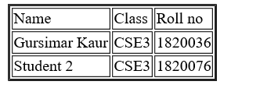

**Experiment-6**

**Aim: Develop a registration form by using various form elements like input box, text area, radio buttons, check boxes etc.**

Following code will produce a Form : >

<!DOCTYPE html>

<html lang="en">

<head>

<title>Music</title>

<link rel="stylesheet" type="text/css" href="styles/main_style.css">

</head>

<body>

<div class="super_container">

<!-- Header -->

<header class="header">

<div class="logo">

<img src="images/logo.png" style="height: 100px; width: 100px">

</div>

<div>

<span class="logo_text">Music</span>

</div>

<div style="margin-left: 30%;">

<!-- Main Navigation -->

<nav class="topnav">

<ul>

<li class="active"><a href="index.html">Home</a></li>

<li><a href="artists.html">Artists</a></li>

<li><a href="blog.html">Latest Release</a></li>

<li><a href="contact.html">Contact</a></li>

</ul></nav>

<!-- User area -->

<div class="topnav" style="margin-left: 20%; float: left;">

<ul>

<li><a href="login.html">Login</a></li>

<li><a href="register.html">Register</a></li>

</ul>

</div></div>

</header></div>

<div style="margin-top: 10%;">

<center>

<h1 style="color: #3b125d">Registration Form</h1>

<form style="font-size: 19px; border-width: 2px; border-radius: 5px; width: 30%; padding: 20px; background-color: #f2f2f2;" action=”submit.html”>

<table><tr><td><br>Name: </td>

<td><br><input type="text" id="name" required style="width: 200px; height: 20px;" placeholder="Enter your name..."></td></tr><tr>

<td><br>Email ID: </td>

<td><br><input type="email" id="email" required style="width: 200px; height: 20px;" placeholder="Enter your email id..."></td></tr><tr>

<td><br>Age: </td>

<td><br>

<input type="number" id="age" required style="width: 200px; height: 20px;" placeholder="Enter your age..."></td></tr><tr>

<td><br>Gender: </td>

<td> <br>

<select>

<option>Male</option>

<option>Female</option>

<option>Trans-Gender</option>

</select>

</td></tr><tr>

<td><br>Music Genre: </td>

<td><br>

<input type="checkbox" name="hiphop" value="hiphop"> Hip Hop<br>

<input type="checkbox" name="jaz" value="jaz"> Jaz<br>

<input type="checkbox" name="rock" value="rock" checked>Rock<br>

<input type="checkbox" name="electro" value="electro">Electro<br>

<input type="checkbox" name="electronic" value="electronic">Electronic<br>

<input type="checkbox" name="pop" value="pop" checked>Pop<br></td>

</tr><tr><td><br>Password: </td>

<td><br><input type="password" id="password" required style="width: 200px; height: 20px;" placeholder="Set a password..."></td></tr>

</table><br>

<button>SUBMIT</button>

</form></center></div>

</body>

</html>

**OUTPUT :**

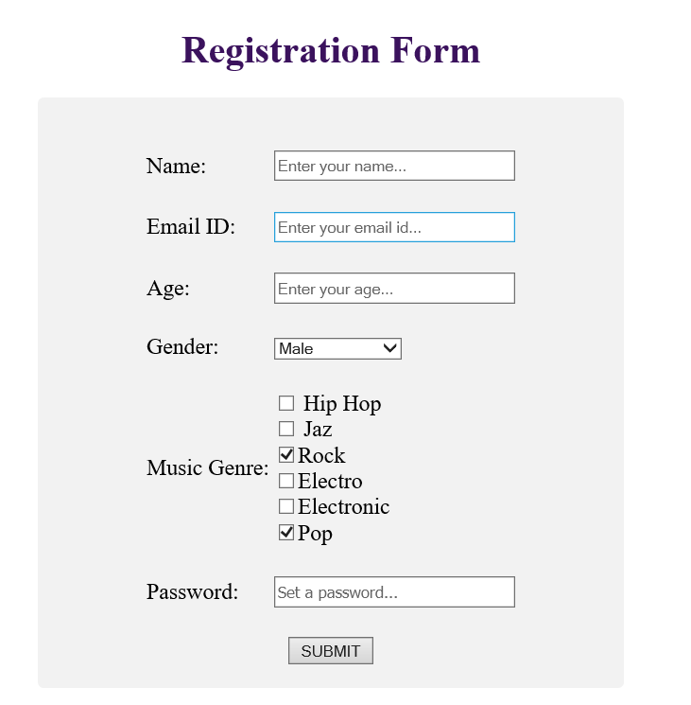

**Experiment-7**

**Aim: Implement login page contains the user name and the password of the user to authenticate.**

<!DOCTYPE html>

<html lang="en">

<head>

<title>Music</title>

<link rel="stylesheet" type="text/css" href="styles/main_style.css">

</head>

<body>

<div class="super_container">

<!-- Header -->

<header class="header">

<div class="logo">

<img src="images/logo.png" style="height: 100px; width: 100px">

</div><div>

<span class="logo_text">Music</span>

</div><div style="margin-left: 30%;">

<!-- Logo --><!-- Main Navigation -->

<nav class="topnav">

<ul>

<li class="active"><a href="index.html">Home</a></li>

<li><a href="artists.html">Artists</a></li>

<li><a href="blog.html">Latest Release</a></li>

<li><a href="contact.html">Contact</a></li>

</ul>

</nav><!-- User area -->

<div class="topnav" style="margin-left: 20%; float: left;">

<ul>

<li><a href="login.html">Login</a></li>

<li><a href="register.html">Register</a></li>

</ul>

</div>

</div>

</header>

</div>

<div style="margin-top: 10%;">

<center>

<h1 style="color: #3b125d">Login Form</h1>

<form style="font-size: 19px; border-width: 2px; border-radius: 5px; width: 30%; padding: 20px; background-color: #f2f2f2;" >

<table>

<tr>

<td rowspan="7">

<img src="images/login.png" style="height: 120px; width: 100px; padding: 5px;">

</td>

</tr><tr>

<td>Email ID: </td>

<td><input type="email" id="email" required style="width: 200px; height: 20px;" placeholder="Enter your email id..."></td>

</tr><tr><td>Password: </td>

<td><input type="password" id="password" required style="width: 200px; height: 20px;" placeholder="Enter your password..."></td>

</tr></table>

<button>SUBMIT</button>

</form></center>

</div>

</body>

</html>

**OUTPUT :**

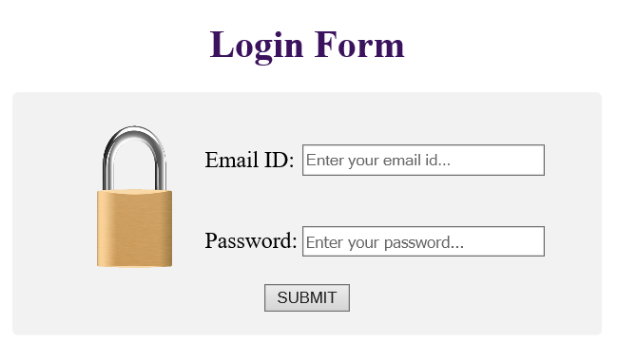

**Experiment-8**

**Aim: Design an HTML page by using the concept of internal, inline, external style sheets.**

Following code will illustrate use of inline, internal and external style sheets :>

**External CSS**

External styles are defined within the <link> element, inside the <head> section of an HTML page:-

<!DOCTYPE html>

<html>

<head>

<link rel="stylesheet" type="text/css" href="mystyle.css">

</head>

<body>

<h1>Hello</h1>

<p>This is my new webpage</p>

</body>

</html>

**Here is how the "mystyle.css" file looks like:**

**"mystyle.css"**

**body {  
  background-color: lightblue;  
}  
  
h1 {  
  color: navy;  
  margin-left: 20px;  
}**

**OUTPUT :**

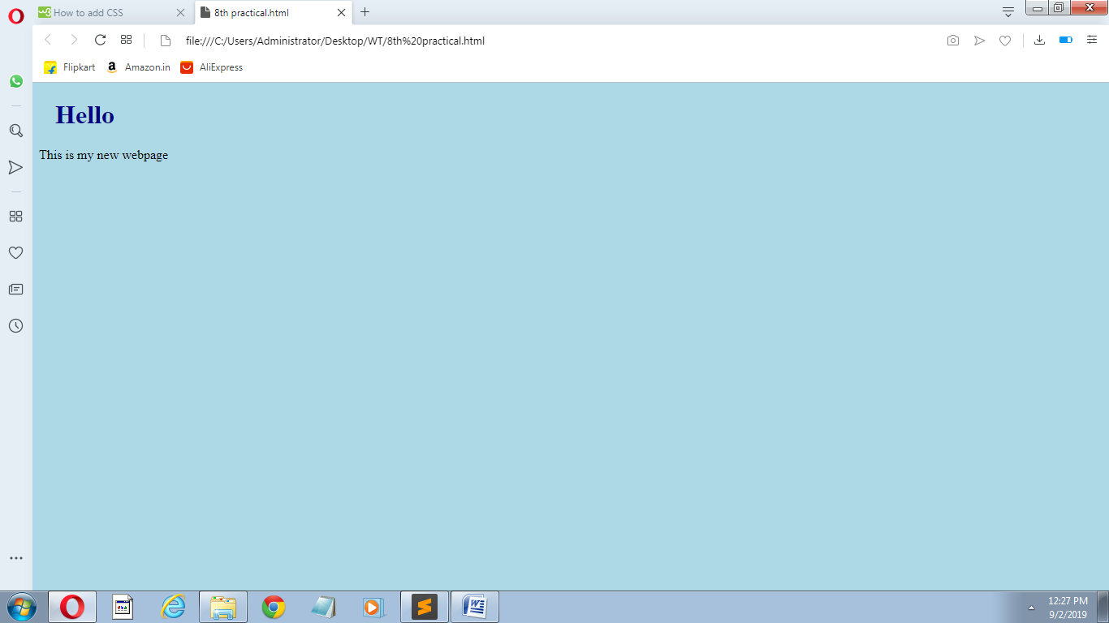

**Internal CSS**

Internal styles are defined within the <style> element, inside the <head> section of an HTML page:

<!DOCTYPE html>

<html>

<head>

<style>

body {

background-color: linen;

}

h1 {

color: maroon;

margin-left: 40px;

}

</style>

</head>

<body>

<h1>Hey</h1>

<p>This is internal.</p>

</body></html>

**OUTPUT :**

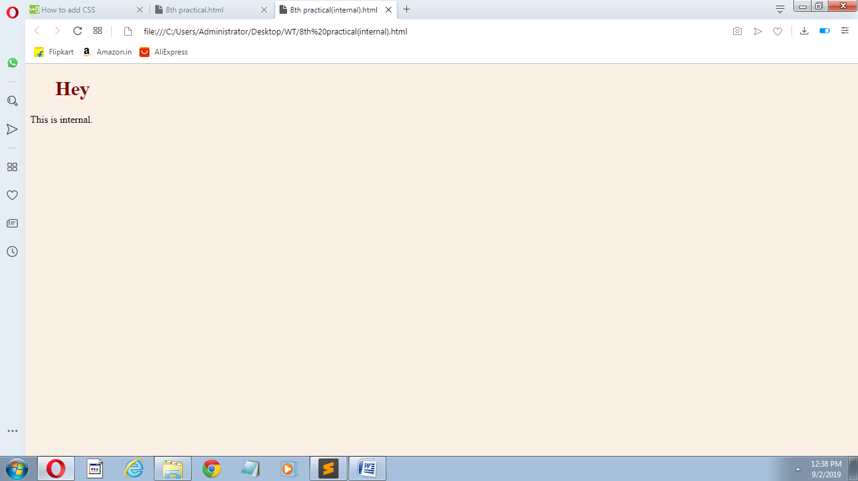

**Inline CSS**

Inline styles are defined within the "style" attribute of the relevant element:

<!DOCTYPE html>

<html>

<body>

<h1 style="color:blue;text-align:center;">Hi</h1>

<p style="color:red;">This is inline.</p>

</body>

</html>

**OUTPUT :**

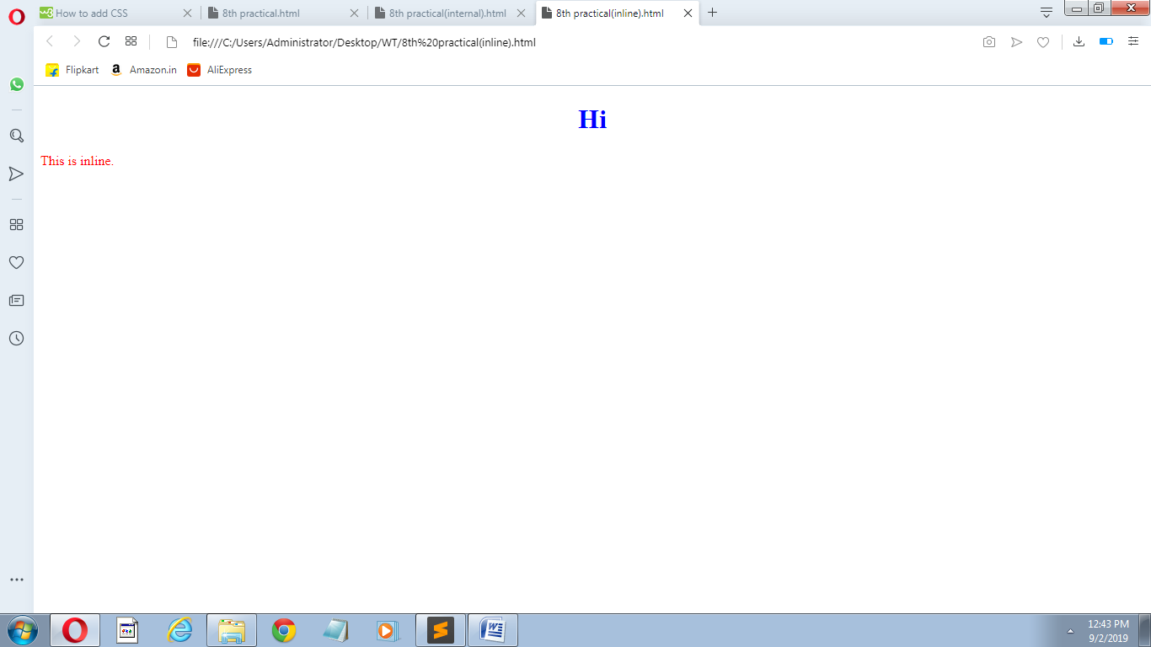

**Experiment-9**

**Aim: Create a html file to implement the styles related to text, fonts, links using CSS.**

Following code will illustrate styles related to text, fonts, links using CSS :>

**Styles related to text using CSS:>**

<!DOCTYPE html>

<html>

<head>

<style>

body {

color: blue;

}

h1 {

color: green;

}

p.uppercase {

text-transform: uppercase;

}

div {

border: 1px solid black;

padding: 10px;

width: 200px;

height: 300px;

text-align: justify;

}

</style>

</head>

<body>

<h1>Hey</h1>

<p class="uppercase">This is css text.<br>

We are justifying the text.</br></p>

<div>Lorem ipsum dolor sit amet, consectetur adipisicing elit, sed do eiusmod

tempor incididunt ut labore et dolore magna aliqua. Ut enim ad minim veniam,

quis nostrud exercitation ullamco laboris nisi ut aliquip ex ea commodo

consequat. Duis aute irure dolor in reprehenderit in voluptate velit esse

cillum dolore eu fugiat nulla pariatur. Excepteur sint occaecat cupidatat non

proident, sunt in culpa qui officia deserunt mollit anim id est laborum.</div>

</body>

</html>

**OUTPUT :**

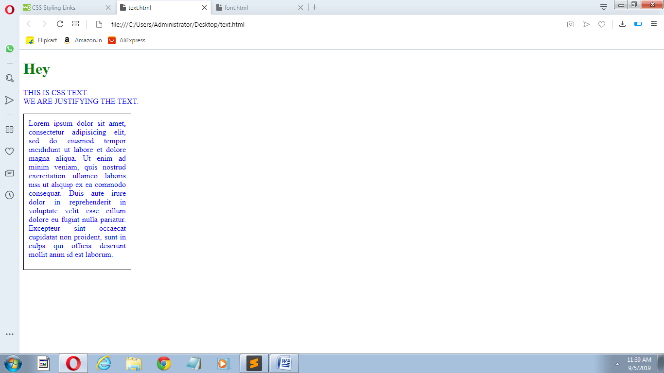

**Styles related to font using css:>**

<!DOCTYPE html>

<html>

<head>

<style>

body {

font-size: 100%;

}

h1 {

font-size: 40px;

}

p.serif {

font-family: "Times New Roman", Times, serif;

}

</style>

</head>

<body>

<h1>Hello</h1>

<p class="serif">This is css font.</p>

</body>

</html>

**OUTPUT :**

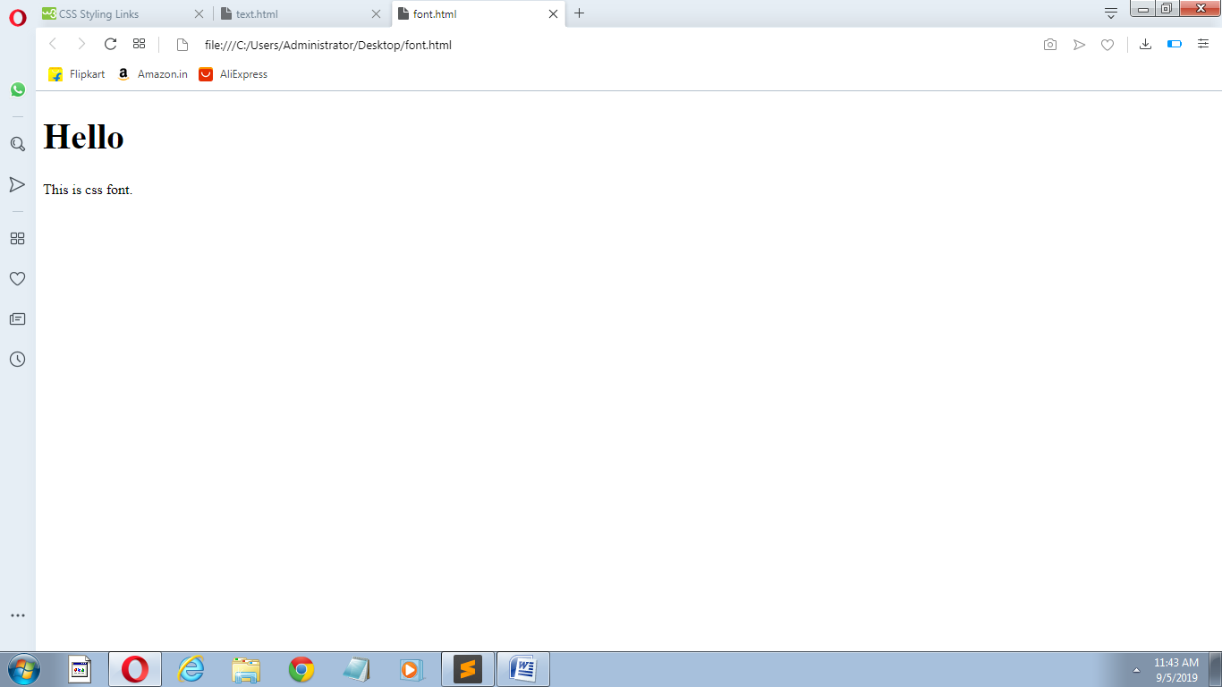

**Styles related to link using css:>**

<!DOCTYPE html>

<html>

<head>

<style>

a:link, a:visited {

background-color: #f44336;

color: white;

padding: 14px 25px;

text-align: center;

text-decoration: none;

display: inline-block;

}

a:hover, a:active {

background-color: red;

</style>

</head>

<body>

<p><b><a href="9th practical(text).html">This is a link</a></b></p>

</body>

</html>

**OUTPUT :**

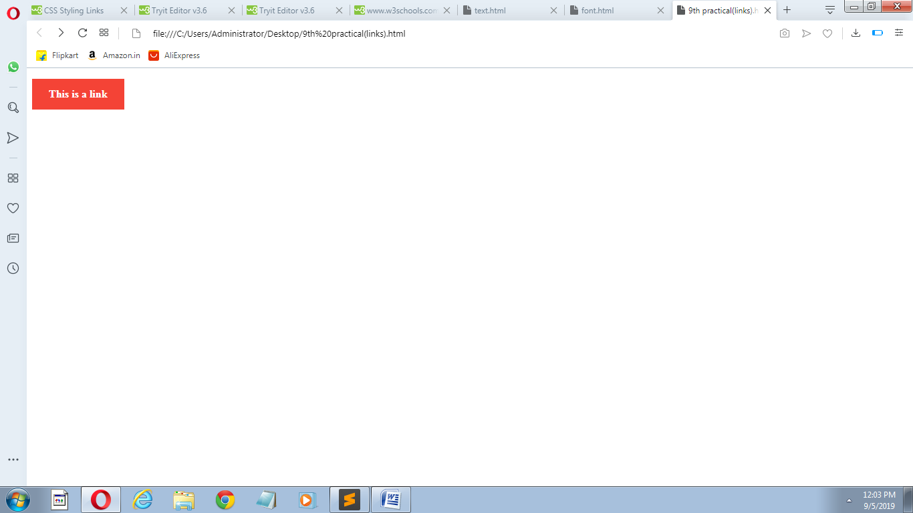

**Experiment 10.**

**Aims: Develop an HTML file to implement styles related to lists, tables using CSS.**

Following code will illustrate styles related to lists, tables using CSS :>

**Styles related to lists using CSS:>**

<!DOCTYPE html>

<html>

<head>

<style>

ol {

background: #ff9999;

padding: 20px;

}

ul {

background: #3399ff;

padding: 20px;

}

ol li {

background: #ffe5e5;

padding: 5px;

margin-left: 35px;

}

ul li {

background: #cce5ff;

margin: 5px;

}

</style>

</head>

<body>

<h1>Styling Lists With Colors:</h1>

<ol>

<li>Coffee</li>

<li>Tea</li>

<li>Coca Cola</li>

</ol>

<ul>

<li>Coffee</li>

<li>Tea</li>

<li>Coca Cola</li>

</ul>

</body>

</html>

**OUTPUT :**

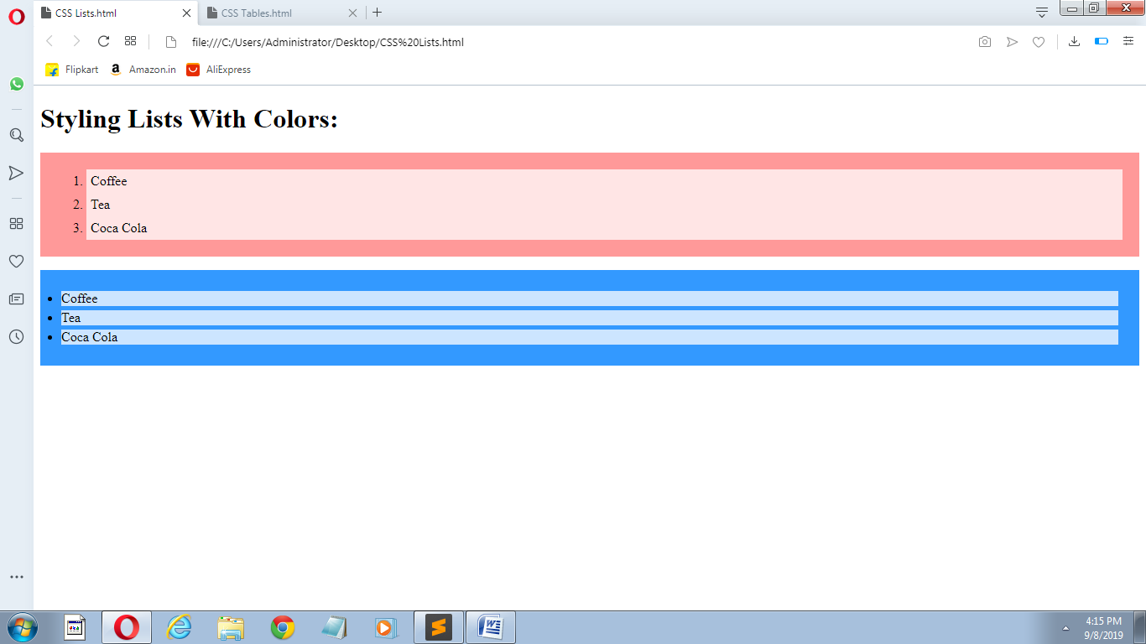

**Styles related to tables using css:>**

<!DOCTYPE html>

<html>

<head>

<style>

table {

border-collapse: collapse;

width: 100%;

}

th, td {

text-align: left;

padding: 8px;}

tr:nth-child(even) {background-color: #f2f2f2;}

</style>

</head>

<body>

<div style="overflow-x:auto;">

<table>

<tr><th>First Name</th>

<th>Last Name</th>

<th>Points</th>

<th>Points</th>

<th>Points</th>

<th>Points</th>

<th>Points</th>

<th>Points</th>

<th>Points</th>

<th>Points</th>

<th>Points</th>

<th>Points</th></tr>

<tr><td>Jill</td>

<td>Smith</td>

<td>50</td>

<td>50</td>

<td>50</td>

<td>50</td>

<td>50</td>

<td>50</td>

<td>50</td>

<td>50</td>

<td>50</td>

<td>50</td>

</tr><tr>

<td>Eve</td>

<td>Jackson</td><td>94</td><td>94</td><td>94</td><td>94</td><td>94</td>

<td>94</td><td>94</td><td>94</td><td>94</td><td>94</td>

</tr><tr>

<td>Adam</td>

<td>Johnson</td>

<td>67</td><td>67</td><td>67</td><td>67</td><td>67</td><td>67</td>

<td>67</td><td>67</td><td>67</td><td>67</td> </tr>

</table>

</div>

</body>

</html>

**OUTPUT :**

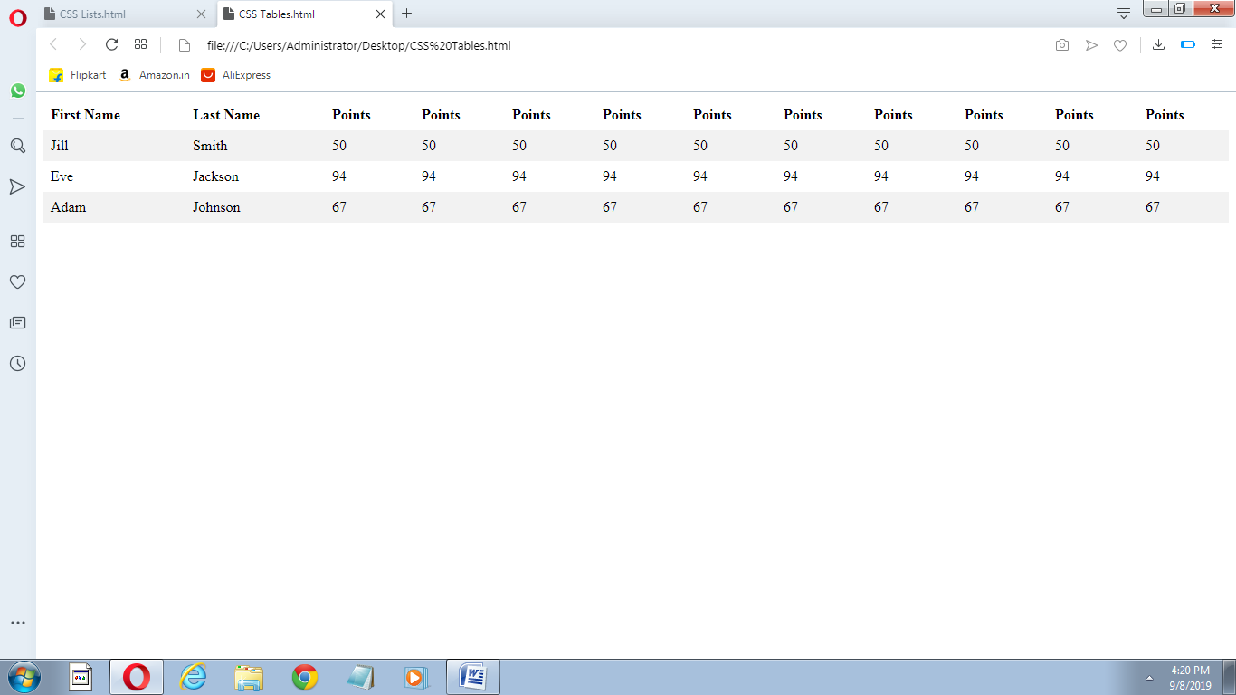

**Experiment 11.**

**Aim: Create an HTML page to implement concept of DOM using JavaScript.**

Following code will implement concept of DOM using javascript:>

<html>

<head>

<title>DOM</title>

</head>

<body>

<h1 id="one">Welcome</h1>

<p>This is the welcome message.</p>

<script type="text/javascript">

var text = document.getElementById("one").innerHTML;

alert("The first heading is " + text);

</script>

</body>

</html>

**OUTPUT :**

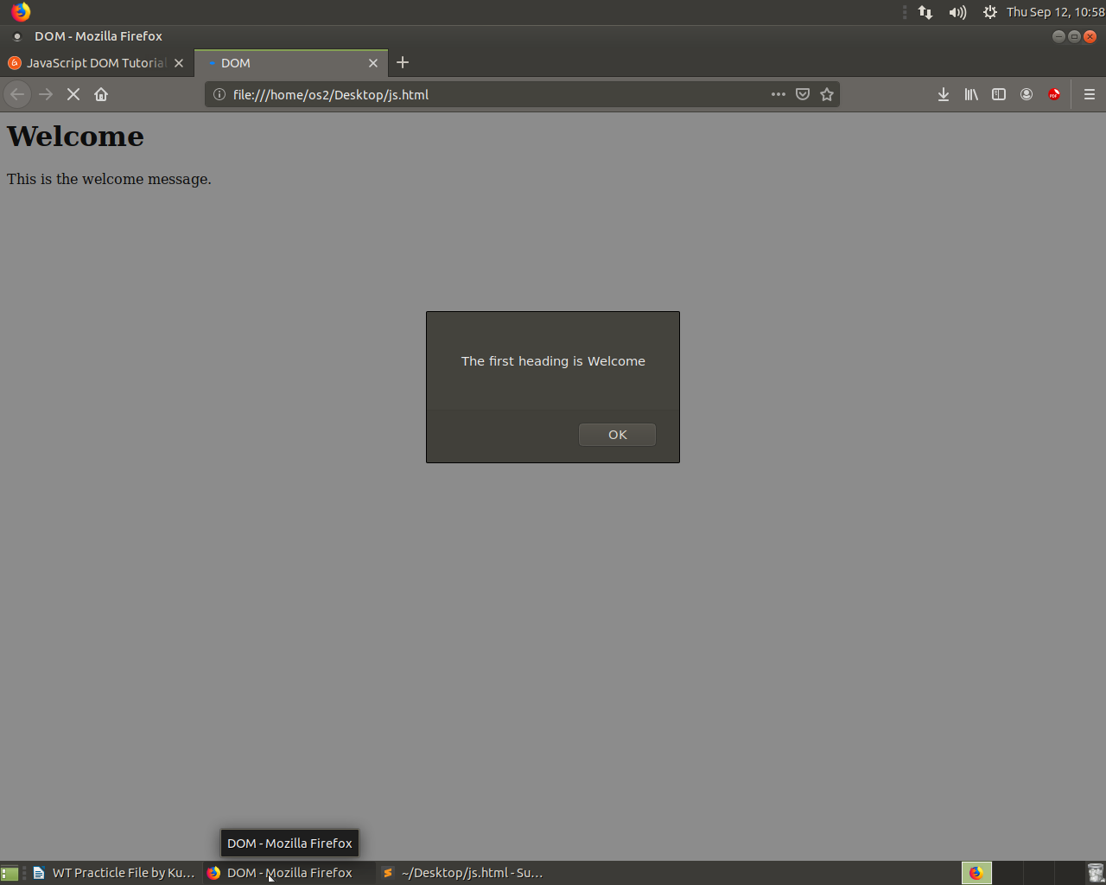

**Experiment 12.**

**Aim: Create an HTML file to display various arithmetic operations on variables in JavaScript.**

Following code will display various arithmetic operations on variables in JavaScript:>

<!DOCTYPE html>

<html>

<head><title>Javascript Arithmetic Operators</title></head>

<body><h1>Performing Arithmetic Operations </h1>

<script> var a = 12, b = 3;

var add, sub, multiply, divide, mod;

add = a + b; //adding 3 and 12.

sub = a - b; //subtracting 3 from 12.

multiply = a * b; //Multiplying both the numbers.

divide = a / b; //dividing 12 by 3.

mod = a % b; //calculating the remainder.

document.write("Here we have taken a=12 and b=3" + "</br>");

document.write("Addition of " + a +' and ' + b +" is = " + add + "<br />");

document.write("Subtraction of " + a +' and ' + b +" is = " + sub + "<br />");

document.write("Multiplication of " + a +' and ' + b +" is = " + multiply + "<br/>");

document.write("Division of " + a +' and ' + b +" is = " + divide + "<br />");

document.write("Modulus of " + a +' and ' + b +" is = " + mod + "<br />");

</script></body></html>

**OUTPUT :**

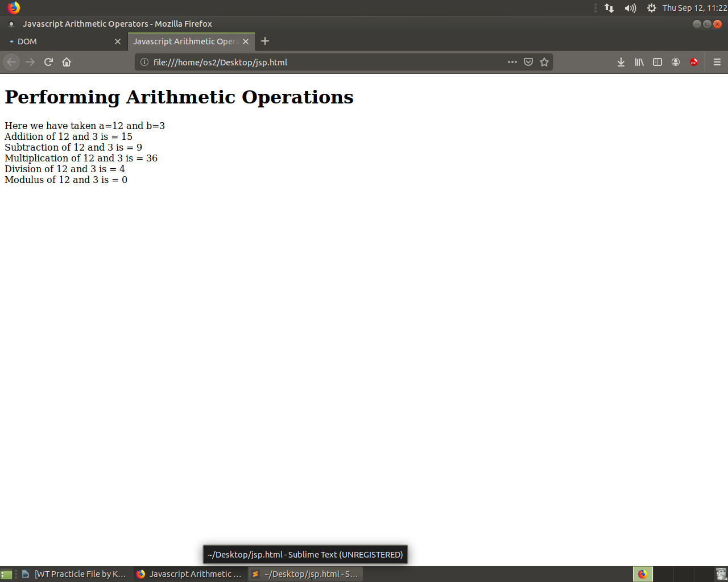

**Experiment 13.**

**Aim: Create an HTML file to implement alert, confirm, dialog box using JavaScript.**

Following code will implement alert, confirm, dialog box using JavaScript.

<!DOCTYPE html>

<html>

<head>

</head>

<body>

<h2>JavaScript Alert, confirm & Prompt</h2>

<button onclick="myFunction()">Try it</button>

<p id="demo"></p>

<script>

function myFunction()

{

var txt;

var person = prompt("Please enter your name:", "Harry Potter");

if (person == null || person == "")

{

txt = "User cancelled the prompt.";

}

else

{

txt = "Hello " + person + "! How are you today?";

}

document.getElementById("demo").innerHTML = txt;

}

</script>

</body>

</html>

**OUTPUT :**

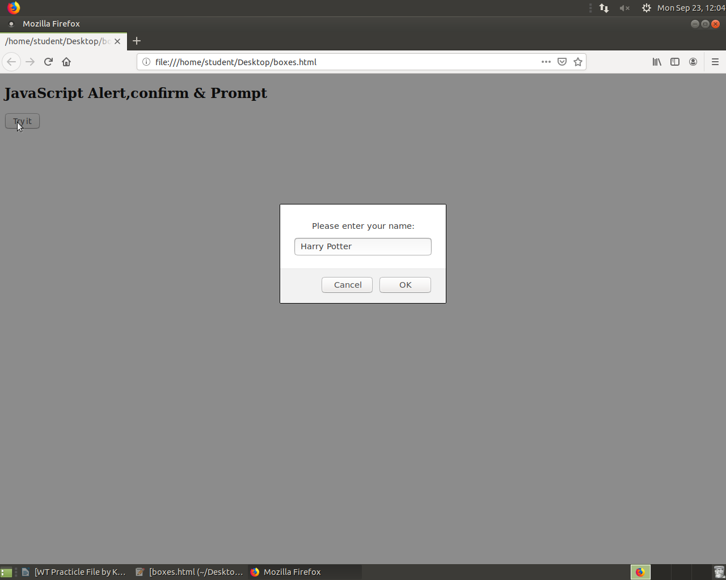

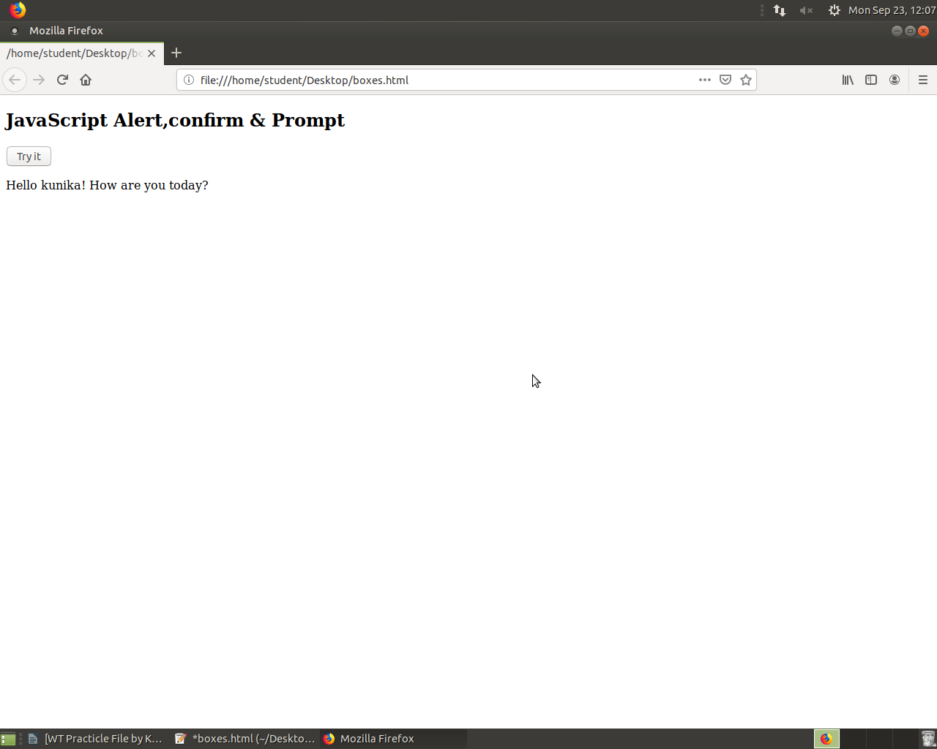

**Experiment 14.**

**Aim:** **Create an HTML file to implement concept of functions and arrays using JavaScript.**

Following code Demonstrates concept of Functions and arrays :

<!DOCTYPE html>

<html lang="en">

<head><meta charset="UTF-8">

<meta name="viewport" content="width=device-width, initial-scale=1.0">

<meta http-equiv="X-UA-Compatible" content="ie=edge">

<title>Document</title>

</head>

<body><script>

function showArray(a){

for(var i=0;i<a.length;i++){

console.log(a[i]);}}

var a = [1,7,6,5,5]; //array

showArray(a);

</script></body></html>

**OUTPUT :**

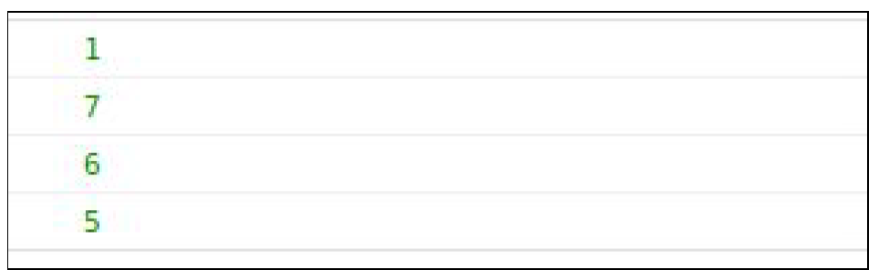

**Experiment 15.**

**Aim: Implement a user defined function in JavaScript to get array of values and sort them in ascending order.**

Following code sorts an array of integers :

<!DOCTYPE html>

<html lang="en">

<head>

<meta charset="UTF-8">

<meta name="viewport" content="width=device-width,

initial-scale=1.0">

<meta http-equiv="X-UA-Compatible" content="ie=edge">

<title>Document</title>

</head>

<body>

<script>

function sortArray(a){

return a.sort((a,b) => {return a-b});

}

var values = prompt("Enter Array Values : ");

values = values.split(" ").map(Number);

sortArray(values);

console.log(sortArray(values));

</script>

</body>

</html>

**OUTPUT :**

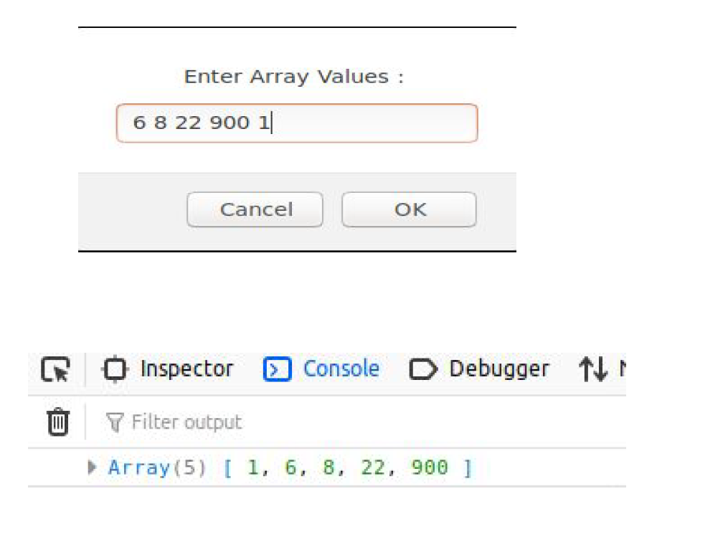

**Experiment 16.**

**Aim:** **Demonstrate the use of control statements and loops in**

**JavaScript.**

Following Code Demonstrates use of if else statement :

<!DOCTYPE html>

<html lang="en">

<head>

<meta charset="UTF-8">

<meta name="viewport" content="width=device-width,

initial-scale=1.0">

<meta http-equiv="X-UA-Compatible" content="ie=edge">

<title>Document</title>

</head>

<body>

<script>

var a = 5;

if(a>10){

console.log("a is more than 10");

}

else if(a==5){

console.log("a is equal to 5");

}

else{

console.log("a is less than 5");

}

</script>

</body>

</html>

**OUTPUT :**

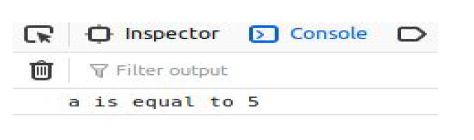

Following Code Demonstrates use of switch :

<!DOCTYPE html>

<html lang="en">

<head>

<meta charset="UTF-8">

<meta name="viewport" content="width=device-width,

initial-scale=1.0">

<meta http-equiv="X-UA-Compatible" content="ie=edge">

<title>Document</title>

</head>

<body>

<script>

var vowel = prompt("Enter a character : ");

switch(vowel){

case 'a':

case 'e':

case 'i':

case 'o':

case 'u':

console.log("this is a vowel");

break;

default:

console.log("its a consonent");}

</script>

</body>

</html>

**OUTPUT :**

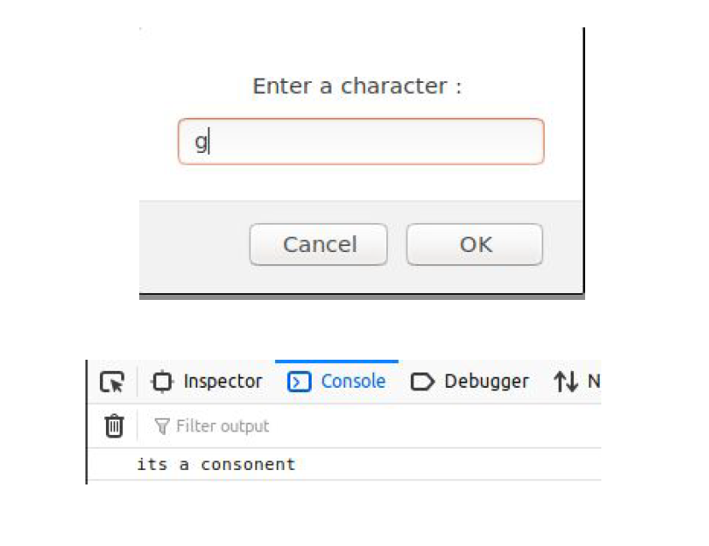

Following Code Demonstrates use of loops :

<!DOCTYPE html>

<html lang="en">

<head>

<meta charset="UTF-8">

<meta name="viewport" content="width=device-width,

initial-scale=1.0">

<meta http-equiv="X-UA-Compatible" content="ie=edge">

<title>Document</title>

</head>

<body>

<script>

for(var i=5;i>=0;i--){ //for loop

console.log(" ".repeat(i) + "*".repeat(5-i))

}

var j = 6;

while(j-- > 0){ //while loop

console.log("*".repeat(j) + " ".repeat(5-j));

}

var table = 7,j = 1;

do{ //do while loop

console.log(`${table} * ${j} = ${table * j}`);

}while(j++ <= 10);

</script>

</body>

</html>

**OUTPUT :**

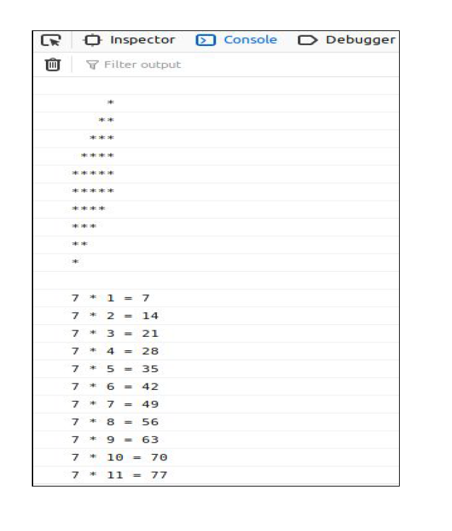

**Experiment 17.**

**Aim: Demonstrate string and math object’s predefined methods using JavaScript.**

Following Code Demonstrates use of string functions :

<!DOCTYPE html>

<html lang="en">

<head>

<meta charset="UTF-8">

<meta name="viewport" content="width=device-width,

initial-scale=1.0">

<meta http-equiv="X-UA-Compatible" content="ie=edge">

<title>Document</title>

</head>

<body>

<script>

var demo = "this is a string";

console.log("length of string : " + String(demo.length));

console.log("using indexOf() : " + String(demo.indexOf("is",4)));

console.log("using charAt() : " + String(demo.charAt(8)));

console.log("using lastIndexOf() : "+String(demo.lastIndexOf("s")));

console.log("using Slice() : "+ String(demo.slice(-4,-1)));

console.log("using substring()" + String(demo.substring(4,9)));

console.log("using replace() : "+String(demo.replace("a","modified")));

</script>

</body>

</html>

**OUTPUT :**

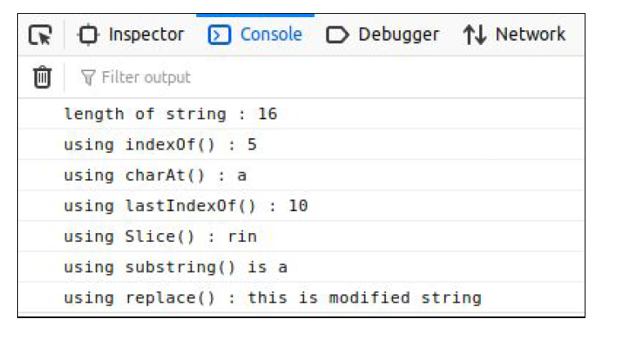

Following Code Demonstrates use of Math functions :

<!DOCTYPE html>

<html lang="en">

<head>

<meta charset="UTF-8">

<meta name="viewport" content="width=device-width,

initial-scale=1.0">

<meta http-equiv="X-UA-Compatible" content="ie=edge">

<title>Document</title>

</head>

<body>

<script>

console.log("using abs() : " + String(Math.abs(-45)));

console.log("using round() : " + String(Math.round(6.9909)));

console.log("using ceil() : " + String(Math.ceil(8.6)));

console.log("using floor() : " + String(Math.floor(8.6)));

console.log("using max() : " + String(Math.max(4,6,7,9,4,3,80)));

console.log("using min() : " + String(Math.ceil(7,6,4,9,8,30)));

console.log("using pow() : " + String(Math.pow(8 , 8)));

console.log("using sqrt() : " + String(Math.sqrt(78)));

</script>

</body>

</html>

**OUTPUT :**

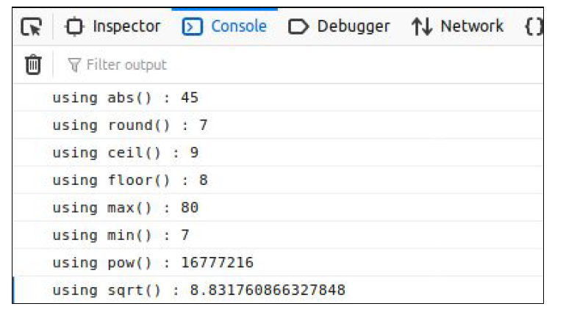

**Experiment 18.**

**Aim: Create a PHP file to print any text using variable.**

Following Code prints text :

<!DOCTYPE html>

<html lang="en">

<head>

<meta charset="UTF-8">

<meta name="viewport" content="width=, initial-scale=1.0">

<meta http-equiv="X-UA-Compatible" content="ie=edge">

<title>Document</title></head>

<body><?php

$a = "this text is stored in a php variable!";

echo "Welcome to php<br>";

echo "this program is to print text using <br>php variable<br>";

echo "text using variable : => ".$a . "<=";

?>

</body>

</html>

**OUTPUT :**

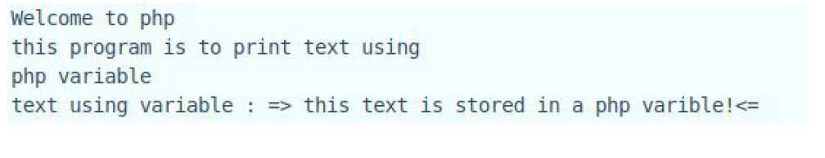

**Experiment 19.**

**Aim: Demonstrate the use of statements, operators and functions in PHP.**

Following Code Demonstrates use of if else :

<!DOCTYPE html>

<html lang="en">

<head>

<meta charset="UTF-8">

<meta name="viewport" content="width=, initial-scale=1.0">

<meta http-equiv="X-UA-Compatible" content="ie=edge">

<title>Document</title>

</head>

<body>

<?php

$a = 5;

if($a == 5){

echo "a is == 5";

}

elseif($a > 5){

echo "a is greater than 5";

}

else{

echo "a is lesser than 5";

}

?>

</body>

</html>

**OUTPUT :**

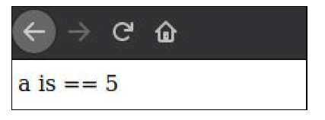

Following Code Demonstrates use of switch :

<!DOCTYPE html>

<html lang="en">

<head>

<meta charset="UTF-8">

<meta name="viewport" content="width=device-width,

initial-scale=1.0">

<meta http-equiv="X-UA-Compatible" content="ie=edge">

<title>Document</title>

</head>

<body>

<?php

$vowel = ‘g’;

switch(vowel){

case 'a':

case 'e':

case 'i':

case 'o':

case 'u':

console.log("this is a vowel");

break;

default:

console.log("its a consonent");

}

?>

</body>

</html>

**OUTPUT :**

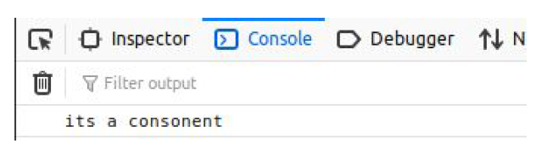

**PHP Operators**

Operators are used to perform operations on variables and values.

PHP divides the operators in the following groups:

● Arithmetic operators

● Assignment operators

● Comparison operators

● Increment/Decrement operators

● Logical operators

Following Program Demonstrates use of all Operators :

<html lang="en">

<head>

<meta charset="UTF-8">

<meta name="viewport" content="width=device-width,

initial-scale=1.0">

<meta http-equiv="X-UA-Compatible" content="ie=edge">

<title>Operators</title>

</head>

<body>

<?php

$x = 10;

echo " x = ".$x."<br>";

$y = 78;

echo " y = ".$y."<br>";

echo "Arithmatic operators : <br>";

echo "x + y = ".($x+$y)."<br>";

echo "x - y = ".($x+$y)."<br>";

echo "x * y = ".($x+$y)."<br>";

echo "x / y = ".($x+$y)."<br>";

echo "x % y = ".($x+$y)."<br>";

echo " Assignment Operators : <br>";

$x += 30;

echo "x += 30".$x."<br>";

$x -= 20;

echo "x -= 20".$x."<br>";

$x *= 25;

echo "x -= 20".$x."<br>";

$x /= 10;

echo " x/= 10 : ".$x."<br>";

echo "x= 10 : ".$x."<br>";

$x = 78;

$y = 10;

echo "Comparison Operators : <br>";

echo "x > y : ".($x>$y)."<br>";

echo "x < y : ".($x<$y)."<br>";

echo "x >= y : ".($x>=$y)."<br>";

echo "x <= y : ".($x<=$y)."<br>";

echo "x == y : ".($x==$y)."<br>";

echo "x === y : ".($x===$y)."<br>";

echo "x != y : ".($x!=$y)."<br>";

echo "x !== y : ".($x!==$y)."<br>";

$x = 78;

$y = 10;

echo "Logical Operators : <br>";

$year = 2014;

// Leap years are divisible by 400 or by 4 but not 100

if(($year % 400 == 0) || (($year % 100 != 0) && ($year % 4 == 0))){

echo "$year is a leap year.<br>";

} else{

echo "$year is not a leap year.<br>";

}

echo " Incrementing and Decrementing Operators : <br>";

$x = 10;

echo "++x : ".++$x."<br>";

echo $x."<br>";

$x = 10;

echo "x++ : ".$x++."<br>";

echo $x."<br>";

$x = 10;

echo "--x: ".--$x."<br>";

echo $x."<br>";

$x = 10;

echo "x-- : ".$x--."<br>";

echo $x."<br>";

?>

</body>

</html>

**OUTPUT :**

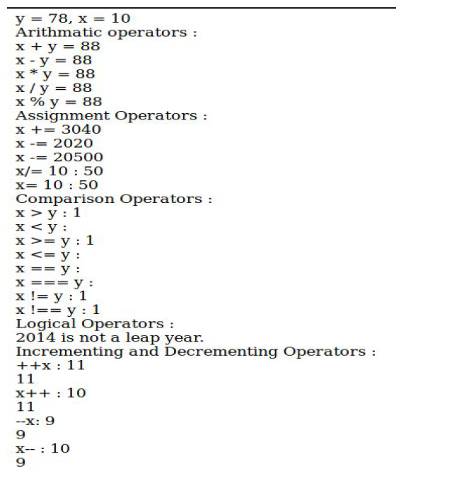

**Pre - Functions in php :**

There are lots of functions in php Here are some basic ans mostly used

functions in php ⇒

● ceil() - Rounds up the supplied float value to the next integer

and returns the result.

● count() - Returns an integer value of the number of elements in

the supplied variable - generally an array, as anything else will return 1.

● die() - Terminates the current script execution.

● echo() - Outputs data to the current stream

● empty() - Used to check if a variable is empty.

● exit() - Exactly the same as die.

● file_get_contents() - Reads a file into a string.

● file_put_contents() - Writes data to a file.

● isset () - check if value of a variable is set or not.

● include() - The include statement includes and evaluates the

specified file.

**User - Defined Functions in php :**

<html lang="en">

<head>

<meta charset="UTF-8">

<meta name="viewport" content="width=device-width, initial-scale=1.0">

<meta http-equiv="X-UA-Compatible" content="ie=edge">

<title>Operators</title>

</head>

<body>

<?php

function hello(){ //DEFINING FUNCTION

echo " this is my first function <br>";

echo " hello world !!!!!!!!";

}

hello(); //CALLING A FUNCTION

?>

</body>

</html>

**OUTPUT :**

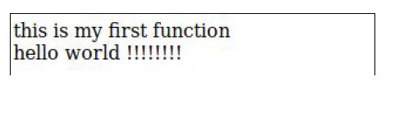

**Experiment 20.**

**Aim: Demonstrate the use of Loops and arrays in PHP.**

Following Program Demonstrates use of for,while and do while loop in php:

<html lang="en">

<head>

<meta charset="UTF-8">

<meta name="viewport" content="width=device-width,

initial-scale=1.0">

<meta http-equiv="X-UA-Compatible" content="ie=edge">

<title>Operators</title>

</head>

<body>

<?php

for($a = 0;$a < 5;$a++){

$i = 0;

while ($i++< $a){

echo "*";

}

echo "<br>";

}

$i =0;

do{

echo "***<br>";

}while($i++ < 5);

?>

</body>

</html>

**OUTPUT :**

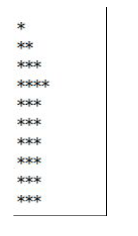

**Experiment 21.**

**Aim: Create a PHP file using GET and POST methods.**

**Code for Post Method :**

form.php

<html>

<head>

<meta charset="UTF-8">

<meta name="viewport" content="width=device-width,

initial-scale=1.0">

<meta http-equiv="X-UA-Compatible" content="ie=edge">

<link rel="stylesheet"

href="https://stackpath.bootstrapcdn.com/bootstrap/4.3.1/css/bootstrap.min

.css"

integrity="sha384-ggOyR0iXCbMQv3Xipma34MD+dH/1fQ784/j6cY/iJTQU

OhcWr7x9JvoRxT2MZw1T" crossorigin="anonymous">

<title>Get And Post</title>

</head>

<body>

<form action="validation.php" method="post">

<div class="form-group" >

<label for="exampleInputEmail1">Email address</label>

<input type="email" class="form-control" name="Email"

id="exampleInputEmail1" aria-describedby="emailHelp" placeholder="Enter

email">

<small id="emailHelp" class="form-text text-muted">We'll never share

your email with anyone else.</small>

</div>

<div class="form-group">

<label for="exampleInputPassword1">Password</label>

<input type="password" class="form-control" name="password"

id="exampleInputPassword1" placeholder="Password">

</div>

<div class="form-group form-check">

<input type="checkbox" class="form-check-input"

id="exampleCheck1">

<label class="form-check-label" for="exampleCheck1">Check me

out</label>

</div>

<button type="submit" class="btn btn-primary">Submit</button>

</form>

</body>

</html>

**After Clicking on Submit button new file will be called that is**

**“validation.php”**

validation.php

<?php

echo "name is : ".$_POST['Email']."<br>";

echo "password is : ".$_POST['password'];

?>

**OUTPUT :**

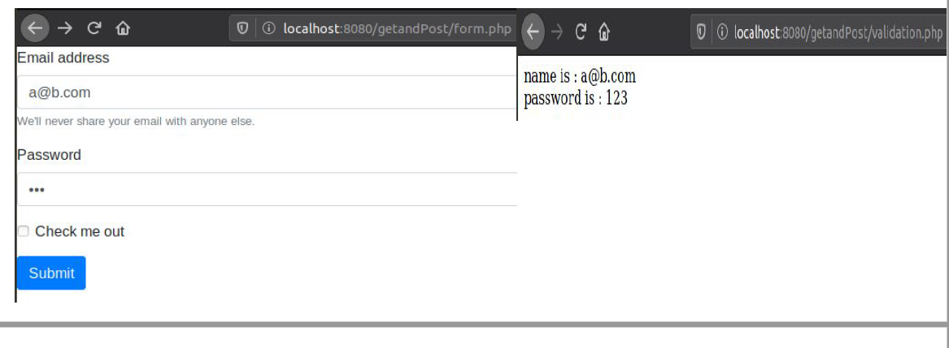

**Code for Get Method :**

form.php

<!DOCTYPE html>

<html lang="en">

<head>

<meta charset="UTF-8">

<meta name="viewport" content="width=device-width,

initial-scale=1.0">

<meta http-equiv="X-UA-Compatible" content="ie=edge">

<link rel="stylesheet"

href="https://stackpath.bootstrapcdn.com/bootstrap/4.3.1/css/bootstrap.min

.css"

integrity="sha384-ggOyR0iXCbMQv3Xipma34MD+dH/1fQ784/j6cY/iJTQU

OhcWr7x9JvoRxT2MZw1T" crossorigin="anonymous">

<title>Get And Post</title>

</head>

<body>

<form action="validation.php" method="GET">

<div class="form-group" >

<label for="exampleInputEmail1">Email address</label>

<input type="email" class="form-control" name="Email"

id="exampleInputEmail1" aria-describedby="emailHelp" placeholder="Enter

email">

<small id="emailHelp" class="form-text text-muted">We'll never share

your email with anyone else.</small>

</div>

<div class="form-group">

<label for="exampleInputPassword1">Password</label>

<input type="password" class="form-control" name="password"

id="exampleInputPassword1" placeholder="Password">

</div>

<div class="form-group form-check">

<input type="checkbox" class="form-check-input"

id="exampleCheck1">

<label class="form-check-label" for="exampleCheck1">Check me

out</label>

</div>

<button type="submit" class="btn btn-primary">Submit</button>

</form>

</body>

</html>

**After Clicking on Submit button new file will be called that is**

**“validation.php”**

Validation.php

<?php

echo "name is : ".$_GET['Email']."<br>";

echo "password is : ".$_GET['password'];

?>

**After Using GET as method We can see the values in the url:**

**OUTPUT :**

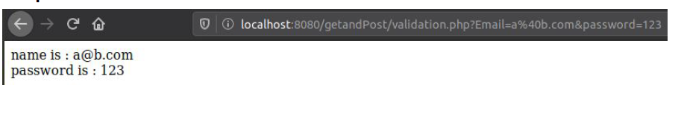

**Experiment 22.**

**Aim: Implement the concept of sessions in PHP.**

To Implements Sessions we will design a simple login and logout using

only one username and password :

We will have 3 files

1. Form.php

2. Validation.php

3. Logout.php

**Code for Form.php :**

<!DOCTYPE html>

<html lang="en">

<head><meta charset="UTF-8">

<meta name="viewport" content="width=device-width,

initial-scale=1.0"><meta http-equiv="X-UA-Compatible" content="ie=edge"><link rel="stylesheet"

href="https://stackpath.bootstrapcdn.com/bootstrap/4.3.1/css/bootstrap.min

.css"

integrity="sha384-ggOyR0iXCbMQv3Xipma34MD+dH/1fQ784/j6cY/iJTQU

OhcWr7x9JvoRxT2MZw1T" crossorigin="anonymous">

<title>Document</title></head>

<body>

<form action= "validation.php" method="post"><div class="form-group">

<label for="username">Username</label>

<input type="text" name="Uname" id="username"

class="form-control" aria-describedby="emailHelp" placeholder="Enter

Username">

<small id="emailHelp" class="form-text text-muted">We'll never share

your Username with anyone else.</small>

</div><div class="form-group">

<label for="password">Password</label>

<input type="password" name="Pass" id="password"

class="form-control" id="exampleInputPassword1"

placeholder="Password">

</div><div class="form-group">

<!-- <p>Don't Have an accout? Sign up <a

href="signup.php">HERE</a></p> -->

</div>

<button type="submit" class="btn btn-primary">Submit</button>

</form>

</body></html>

**For Validation.php :**

<?php

$username = "arsh9806";

$password = 12345;

session_start();

if(isset($_SESSION['Uname'])){

echo "weclome : ".$_SESSION['Uname']."<br>";

echo "You Are Now Logged in !<br>";

echo "To Logout press button below :<br>";

echo "<a href='logout.php'><button>Logout</button></a>";

}

else{

if(isset($_POST['Uname']) && isset($_POST['Pass'])){

if(($_POST['Uname'] == $username)&&($_POST['Pass'] ==

$password)){

$_SESSION['Uname'] = $username;

echo "<script>location.href = 'validation.php'</script>";}

else{

echo "<script>alert(\"username or password incorrect\");</script>";

echo "<script>location.href = 'form.php'</script>";}}

else{

echo "<script>location.href = 'form.php'</script>";}}

?>

**For Logout.php :**

<?php

session_start();

if(isset($_SESSION['Uname'])){

session_destroy();

echo "<script>alert(\"successfully logged out !\")</script>";

echo "<script>location.href = 'form.php'</script>";}

else{echo "<script>location.href = 'form.php'</script>";}

?>

**OUTPUT :**

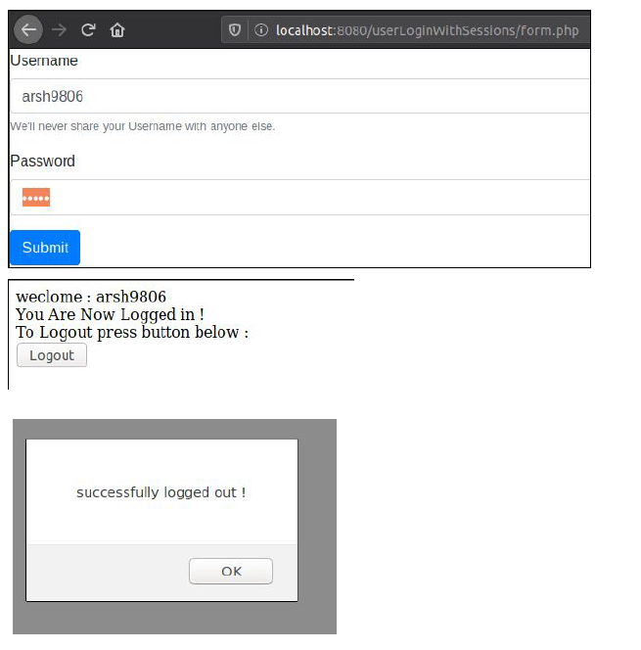

**Experiment 23.**

**Aim: Develop the concept of E-mail in PHP.**

**Code for email form :**

<!DOCTYPE html>

<html lang="en">

<head><meta charset="UTF-8">

<meta name="viewport" content="width=device-width,

initial-scale=1.0">

<meta http-equiv="X-UA-Compatible" content="ie=edge">

<title>Mails</title>

<link rel="stylesheet"

href="https://stackpath.bootstrapcdn.com/bootstrap/4.3.1/css/bootstrap.min

.css"

integrity="sha384-ggOyR0iXCbMQv3Xipma34MD+dH/1fQ784/j6cY/iJTQU

OhcWr7x9JvoRxT2MZw1T" crossorigin="anonymous">

</head>

<body>

<form method="post" action="sendmail.php"><div class="form-group">

<label for="exampleInputEmail1">Email address</label>

<input type="email" class="form-control" id="exampleInputEmail1"

name="email" aria-describedby="emailHelp" placeholder="Enter email">

</div>

<div class="form-group">

<label for="exampleFormControlTextarea1">Enter Message Here

</label>

<textarea class="form-control" name = "text"

id="exampleFormControlTextarea1" rows="3"></textarea>

</div>

<button type="submit" class="btn btn-primary">Send Mail</button>

</form></body>

</html>

**Code for sendmail.php**

<?php

$to_email = 'name @ company.com';

$subject = 'Testing PHP Mail';

$message = 'This mail is sent using the PHP mail function';

$headers = 'From: noreply @ company . com';

mail($to_email,$subject,$message,$headers);

?>

**OUTPUT :**

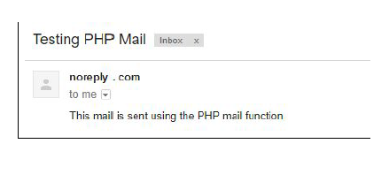

**Experiment 24.**

**Aim: Implement the concept of PHP and MySQL.**

We will make a sign up form to add data to database using my sql

**Signup.php :**

<!DOCTYPE html>

<html lang="en">

<head>

<meta charset="UTF-8">

<meta name="viewport" content="width=device-width,

initial-scale=1.0">

<meta http-equiv="X-UA-Compatible" content="ie=edge">

<link rel="stylesheet"

href="https://stackpath.bootstrapcdn.com/bootstrap/4.3.1/css/bootstrap.min

.css"

integrity="sha384-ggOyR0iXCbMQv3Xipma34MD+dH/1fQ784/j6cY/iJTQU

OhcWr7x9JvoRxT2MZw1T" crossorigin="anonymous">

<title>Document</title>

<style>

/* #exampleInputPassword1{

background-color:lightgreen;

} */

</style>

</head>

<body>

<form action= "server.php" method="post">

<div class="form-group">

<label for="fname">First Name</label>

<input type="text" name="firstname" id="fname" class="form-control"

aria-describedby="emailHelp" placeholder="Enter Firstname" required>

</div>

<div class="form-group">

<label for="lname">Last Name</label>

<input type="text" name="lastname" id="lname" class="form-control"

aria-describedby="emailHelp" placeholder="Enter Lastname" required>

</div>

<div class="form-group">

<label for="uname">Username</label>

<input type="text" name="Uname" class="form-control" id="uname"

aria-describedby="emailHelp" placeholder="Enter Username" required>

</div>

<div class="form-group">

<label for="exampleInputPassword1">Password</label>

<input type="password" name="Pass" class="form-control"

id="exampleInputPassword1" onkeyup="check()" placeholder="Password"

required>

</div>

<div class="form-group">

<label for="exampleInputPassword1">Confirm Password</label>

<input type="password" name="CPass" class="form-control"

id="confirmPassword" onkeyup="check()" placeholder="Confirm Password"

required>

</div>

<button type="submit" class="btn btn-primary">Sign Up</button>

<div class="form-group">

<p>Already a User? Login <a href="form.php">HERE</a></p>

</div>

</form>

<script>

function check(){

if(document.getElementById('exampleInputPassword1').value != "" &&

document.getElementById('confirmPassword').value){

if (document.getElementById('exampleInputPassword1').value

==document.getElementById('confirmPassword').value){

document.getElementById('exampleInputPassword1').style.background =

'lightgreen';

document.getElementById('confirmPassword').style.background =

'lightgreen';

}

else{

document.getElementById('confirmPassword').style.background =

'pink';

}

}

else{

document.getElementById('exampleInputPassword1').style.background =

'pink';

document.getElementById('confirmPassword').style.background = 'pink';

}

}

</script>

</body>

</html>

**Code for AddData.php**

<?php

session_start();

$db = mysqli_connect('localhost','root','','NewUser') or die("Unable to

connect");

//register users

$username = mysqli_real_escape_string($db, $_POST['Uname']);

$firstname = mysqli_real_escape_string($db, $_POST['firstname']);

$lastname = mysqli_real_escape_string($db, $_POST['lastname']);

$Pass = mysqli_real_escape_string($db, $_POST['Pass']);

$CPass = mysqli_real_escape_string($db, $_POST['CPass']);

//handling errors

$errors = array();

//check if user already exists

$user_select_query = "select * from UserRegistration where username =

'$username' limit 1";

$result = mysqli_query($db, $user_select_query);

$user = mysqli_fetch_assoc($result);

if($user){

if($user['username'] === $username){array_push($errors,"username

already taken");}

}

if(count($errors) == 0){

$password = md5($Pass);

mysqli_query($db,"INSERT INTO

UserRegistration(username,firstname,lastname,password)

VALUES('$username','$firstname','$lastname','$password')");

echo "<script>alert(\"Successfully registered. Redirecting to Login

page\"";

header("location:form.php");

}

else{

echo "<script>alert(\"username already taken!\")</script>";

header("location: signup.php");

}

?>

**OUTPUT :**

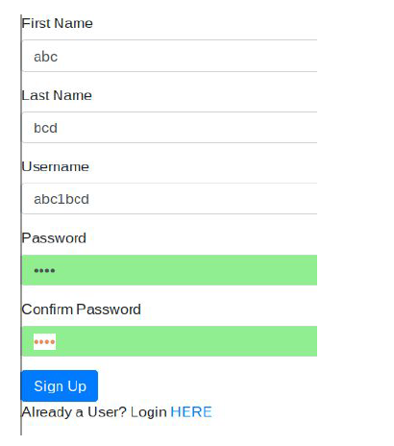

**Values in Database:**

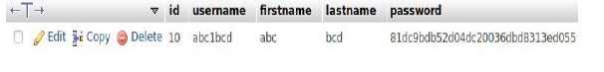

**Experiment 25.**

**Aim: Implement the concept of PHP and AJAX.**

We will design a page which give suggestions about names :

**Code For name.php**

<html>

<head>

<script>

function showHint(str) {

if (str.length == 0) {

document.getElementById("txtHint").innerHTML = "";

return;

} else {

var xmlhttp = new XMLHttpRequest();

xmlhttp.onreadystatechange = function() {

if (this.readyState == 4 && this.status == 200) {

document.getElementById("txtHint").innerHTML =

this.responseText;

}

};

xmlhttp.open("GET", "gethint.php?q=" + str, true);

xmlhttp.send();

}

}

</script>

</head>

<body>

<p><b>Start typing a name in the input field below:</b></p>

<form>

First name: <input type="text" onkeyup="showHint(this.value)">

</form>

<p>Suggestions: <span id="txtHint"></span></p>

</body>

</html>

**Code for gethint.php :**

<?php

// Array with names

$a[] = "Anna";

$a[] = "Brittany";

$a[] = "Cinderella";

$a[] = "Diana";

$a[] = "Eva";

$a[] = "Fiona";

$a[] = "Gunda";

$a[] = "Hege";

$a[] = "Inga";

$a[] = "Johanna";

$a[] = "Kitty";

$a[] = "Linda";

$a[] = "Nina";

$a[] = "Ophelia";

$a[] = "Petunia";

$a[] = "Amanda";

$a[] = "Raquel";

$a[] = "Cindy";

$a[] = "Doris";

$a[] = "Eve";

$a[] = "Evita";

$a[] = "Sunniva";

$a[] = "Tove";

$a[] = "Unni";

$a[] = "Violet";

$a[] = "Liza";

$a[] = "Elizabeth";

$a[] = "Ellen";

$a[] = "Wenche";

$a[] = "Vicky";

// get the q parameter from URL

$q = $_REQUEST["q"];

$hint = "";

// lookup all hints from array if $q is different from ""

if ($q !== "") {

$q = strtolower($q);

$len=strlen($q);

foreach($a as $name) {

if (stristr($q, substr($name, 0, $len))) {

if ($hint === "") {

$hint = $name;

} else {

$hint .= ", $name";

}}}}

// Output "no suggestion" if no hint was found or output correct values

echo $hint === "" ? "no suggestion" : $hint;

?>

**OUTPUT :**

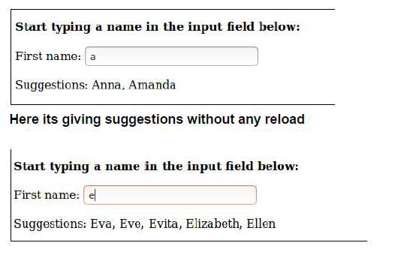

**Experiment 26.**

**Aim: Demonstrate the use of web site designing tools such as joomla, wordpress.**

How to use jhoomla ??

Installing Joomla manually to any web host (step-by-step) :

Download joomla from <https://downloads.joomla.org/us/>



2. Run the manual installation : When all files are on your server, it is now time to open a browser window and input your site URL. If you have done everything right, this should start the Joomla installation process.

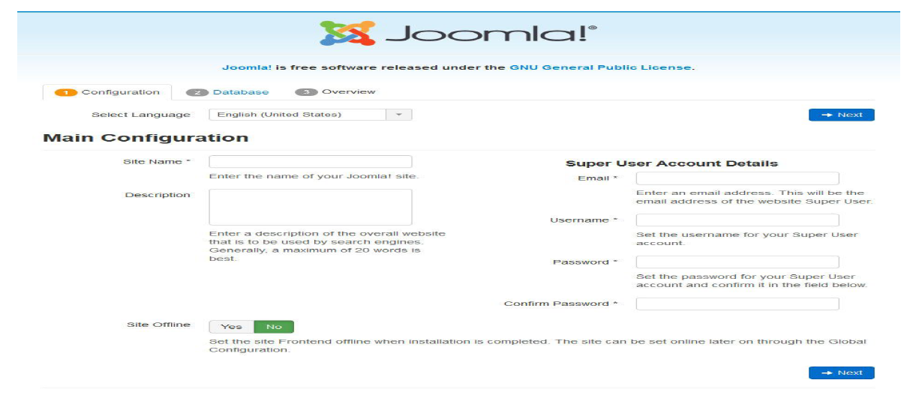

3. Connect Joomla to your MySQL database: Fill in the database information and chick next.

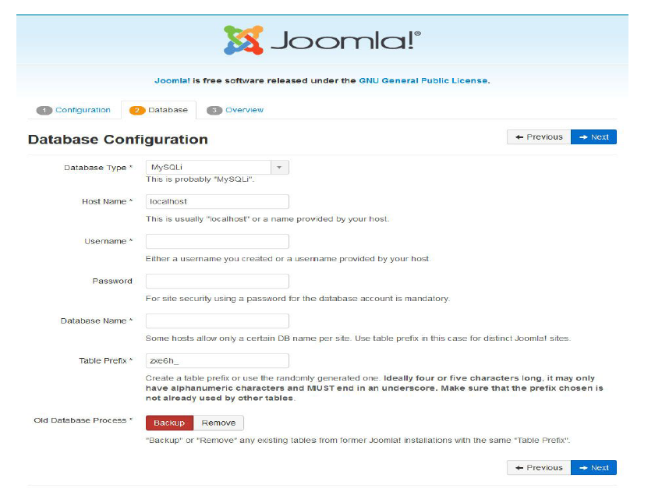

4. The final screen of the Joomla installation is mostly a summary of

everything you have done so far.

5. You will then land on the back end of your Joomla site the so-called

Control Panel . You can also get there via

yourdomain.com/administrator. Now, you can start building and

customizing your Joomla website.

6. Now you need to Select a template for your site and install it.once you

installed the template now, you can start designing your website

**Now let’s see how wordpress is intalled and used :**

WordPress is a content management system (CMS) that allows you to

host and build websites. WordPress contains plugin architecture and a

template system, so you can customize any website to fit your business,

blog, portfolio, or online store.

1. Select a WordPress plan

To begin creating your website, select a WordPress plan. As stated earlier,

with WordPress.org, you only have one (free) plan option — but it requires

you to buy your domain, hosting provider, plugins, themes, and everything

else related to your WordPress site.

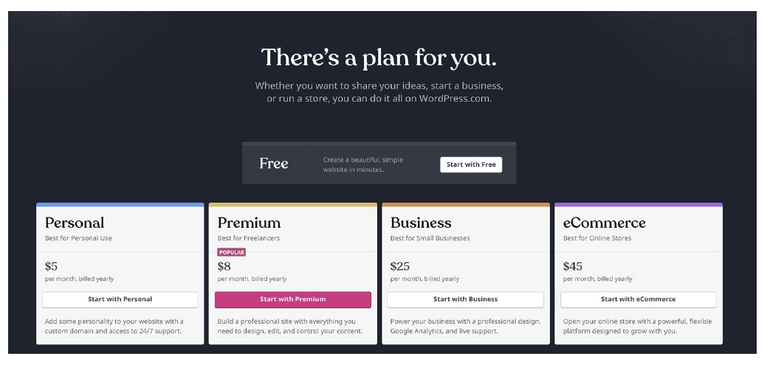

2. Set up your domain name and hosting provider:

Think about your domain name as your home address — it’s how your

visitors are able to locate your website on the Internet.

3. Install WordPress: If you are using a hosting provider outside of WordPress, you’ll need to install the CMS to connect your new domain to your website.

This time, let’s use GoDaddy as an example. (Don’t worry, no matter the

hosting provider you choose, this process looks similar.)

To start, log into your GoDaddy account, click “Web Hosting”, and then

“Manage”. You will be brought to a screen with your account details

Scroll down and under “Options & Settings”, you will see an area titled

“Popular Apps”. Click on the WordPress app to begin the installation.

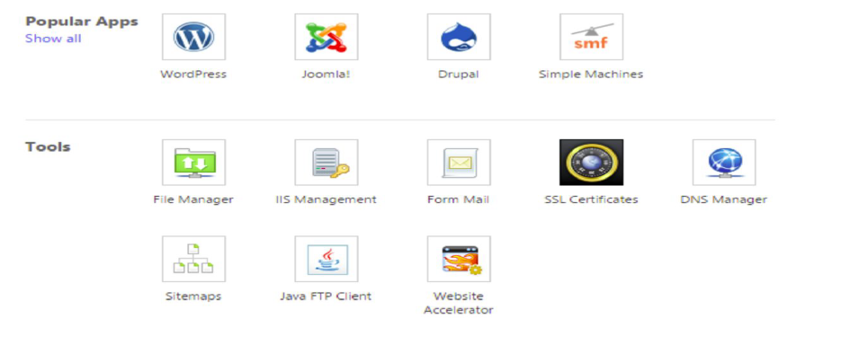

4. Choose your theme: You can customize your website using WordPress’ themes and templates, which contain a multitude of layouts, formatting styles, colors, fonts, and other visual options.

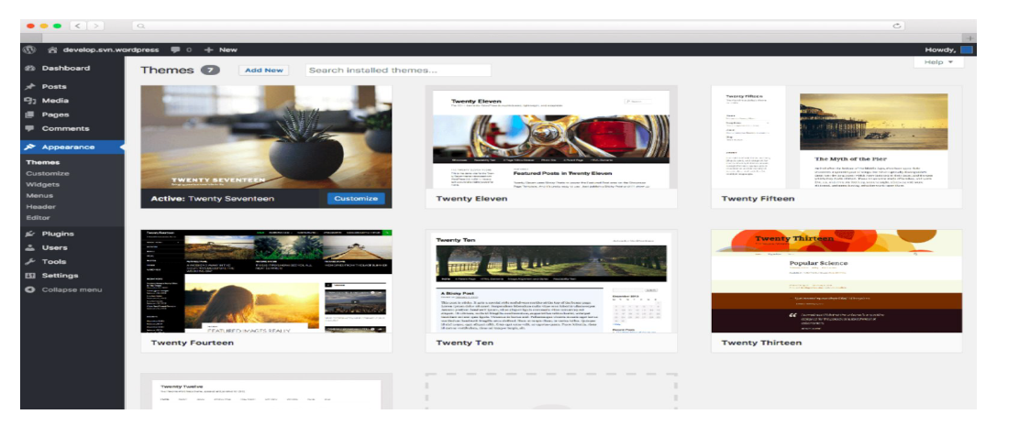

5. Add posts and pages to your website

When you add content to your WordPress website, it’s displayed in the

form of posts and pages.

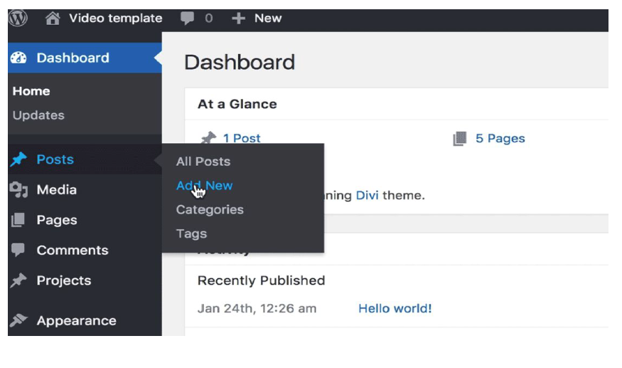

6. Install your plugins and make websites

Plugins are pieces of software that add functionality to your website. They

also enhance the user experience. With over 55,000 available plugins,

there are options for most every type of website and user.

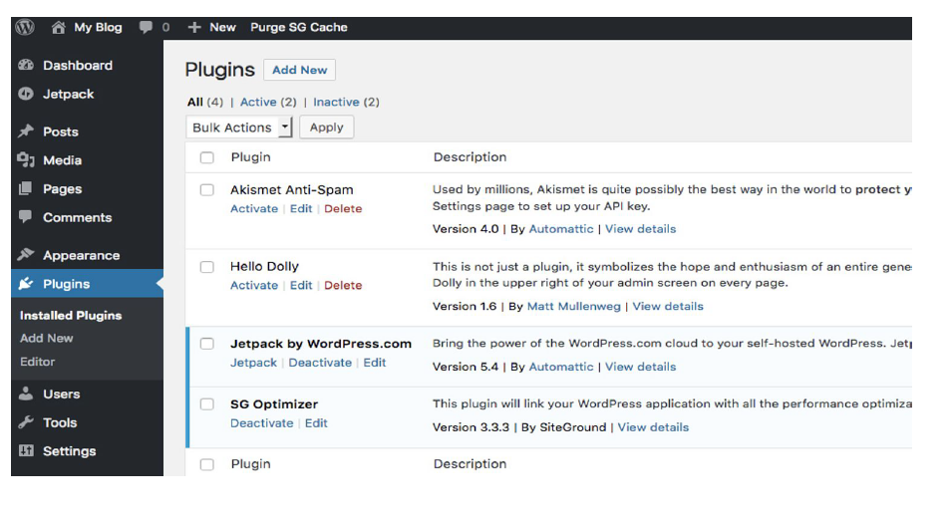

7. Get inspiration from WordPress website examples

As you begin to customize your website, you may feel overwhelmed by all

the possible options. No

worries, you can grab some

inspiration from other highly

engaging WordPress

websites.

